OFFICIAL COORDINATION REQUEST FOR
NON-ROUTINE OPERATIONS AND MAINTENANCE

COORDINATION DATE- Started 19 April 2010
PROJECT- Bonneville Dam
RESPONSE DATE- 30 April 2010

Description of the problem- Juvenile sub-yearling chinook (identification confirmed by PSMFC Smolt Monitoring biologist Dean Ballinger) appear to be trapped between the Smith Root UMT array and the UMT wall/count window. Photos are below.

While the UMT is not generally considered a juvenile passage facility, some juveniles do use the adult ladders to migrate downstream. It is unknown how many juveniles use this route. It is also unknown as to how many juveniles may be trapped between the UMT and the array. The count window exposes a small section of the array on just one side. In addition, it is unknown as to how, exactly, fish are getting between the array and the wall.

On 20 April, BON Fisheries reported that Smith-Root/USGS intend to turn on the array as early as 0900 on 21 April. FPOM is requested to make a recommendation regarding turning on the array while fish are between the array and the UMT wall.

Type of outage required- Unless there are other suggestions, removal of the UMT array appears to be the only feasible way to release the fish. Once the structure is pulled, it may have to remain out until the UMT could be dewatered in the winter.

Impact on facility operation- No impact to the facility other than coordination for array removal. Pulling the array will halt the study Smith Root and USGS had anticipated conducting this year.

Length of time for repairs- Time for removal should be quick but the array has never been removed so exact length of time is unknown.

Expected impacts on fish passage- It is anticipated there will be no negative impacts to adult fish passage.

Juvenile fish passage should improve since there will not be a structure for them to get trapped behind.

Comments from agencies In preliminary conversations, Wills, Fredricks, and Lorz expressed a desire to get the DIDSON test completed before taking action on pulling the array. A preliminary phone call was made to Shane Scott. He indicated he would contact Smith-Root to make them aware of the potential need to pull the array.

(20 April) BPA- Are the fish really trapped or just holding in the void by the window? A question for SR is what will be the impacts on the fish if the array is turned on. The array is designed to have no effect on adult sized fish so my expectation is there would be no impact on juveniles. It would be very easy to monitor since they are very visible in front of the window. The DIDSON would not be needed to answer this question. I wonder if they can remove a downstream piece to ensure there is a way in or out on both sides. Scott Bettin

(21 April) ODFW- From the photos, it appears there are hundreds of fish in just that one areas. Unless the fish are concentrated there because of the light, or whatever, if that is reflective of the density where we can't see the fish, there could be thousands of fish trapped. We don't know how long those fish have been trapped, but they are likely from the recent big slug of hatchery fish. I'm okay with getting the DIDSON test completed before the array is pulled, just so long it is done quickly (a day or so) and the array is not activated. Rick

(21 April) NWP PM-E- I was out at BON yesterday and had the opportunity to see firsthand the trapped juvenile salmonids with Kasey and Jon. Just at the counting window area we observed more than 150+ fish with no apparent way to exit. I suggested to the Project bios that someone needs to be down in the UMT count station when the array is electrified for the first time to document the behavior of the trapped juveniles. Depending on how they react to this first initial jolt it could give us important information as to other impacts that can be expected with much larger targets. I do see these trapped fish as a problem that needs to be remedied so we are not impacting migrating juveniles in our adult passage UMT system. Dennis

(21 April) NWP BON- USGS was planning on having the array on for two hours initially but if they saw enough fish that duration could be shortened. Today was not their first day of testing--it was merely Smith Roots day to figure out the settings and functionality. USGS, however, could start as early as today or tomorrow if Smith Root is ready to go from their end.

(21 April) NOAA Fisheries (Fredricks)- Hold off on turning on the array until more discussion can take place. In addition, Smith-Root does not have ESA coverage for juveniles.

(21 April) USFWS (Wills)- postpone turning on the array at this time. Need more time to evaluate the situation.

(21 April) Shane Scott called, acknowledging the need to postpone turning on the array. He will call Smith-Root to let them know.

Final results-
On 21 April, BON Fisheries reported that the number of fish in the window appear to be the same as earlier in the week. FPOM weighed in and requested the array not be turned on until the group could have a more thorough discussion.

Mackey scheduled a conference call for 21 April to further discuss the issues. FPOM representatives visited the UMT on 22 April and witnessed the reaction of the trapped juveniles to the energizing of the array. Testing was allowed to go forward.

On 26 April, USGS requested a conference call. Mackey scheduled a call for 1400 on 26 April. Based on the results of the USGS DIDSON video, the array was determined to impact migrating adult salmonids. FPOM representatives decided to allow for one more test, after that Smith-Root needed to pull the array as soon as possible.

The UMT array was removed on 28 April.

Thank you,
Tammy Mackey
NWP Operations Division Fishery Section
503-808-4318 or 503-961-5733
Tammy.m.mackey@usace.army.mil
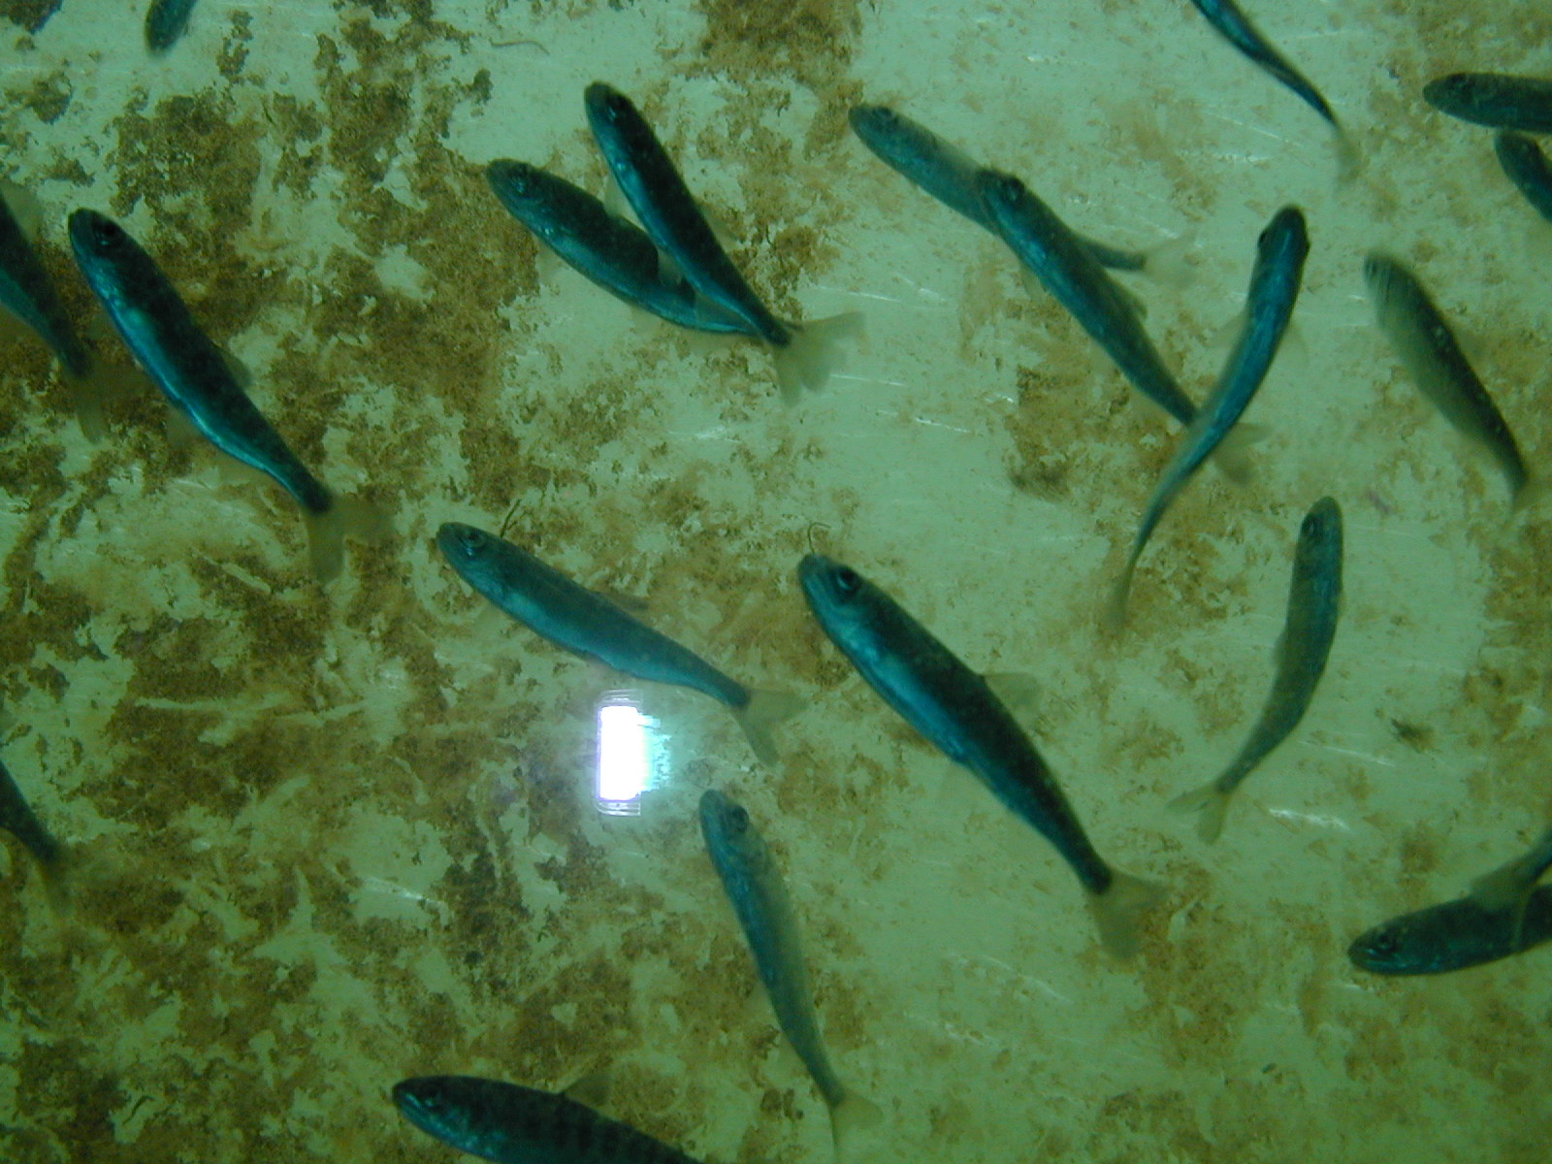
Taken 19 April 2010. BON UMT window

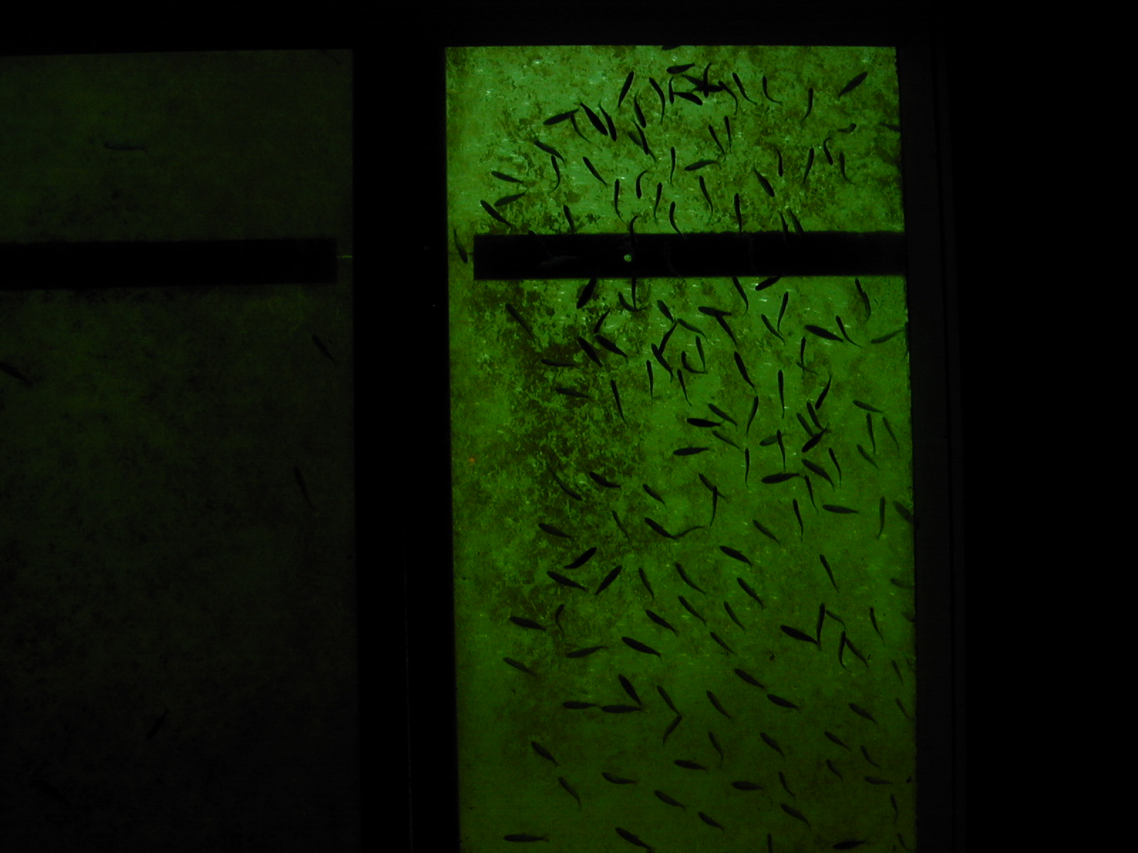
Taken 19 April 2010. BON UMT window, nearly entire window.

